**UNIVERSITY EXAM:**

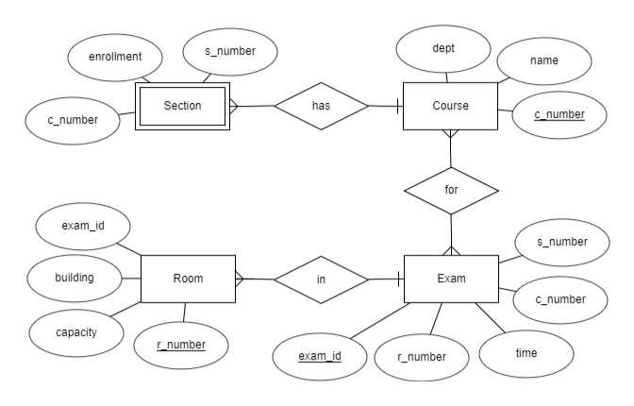

From this ER diagram we can infer that courses has various section, the course has final exams and the exam is held in various rooms.